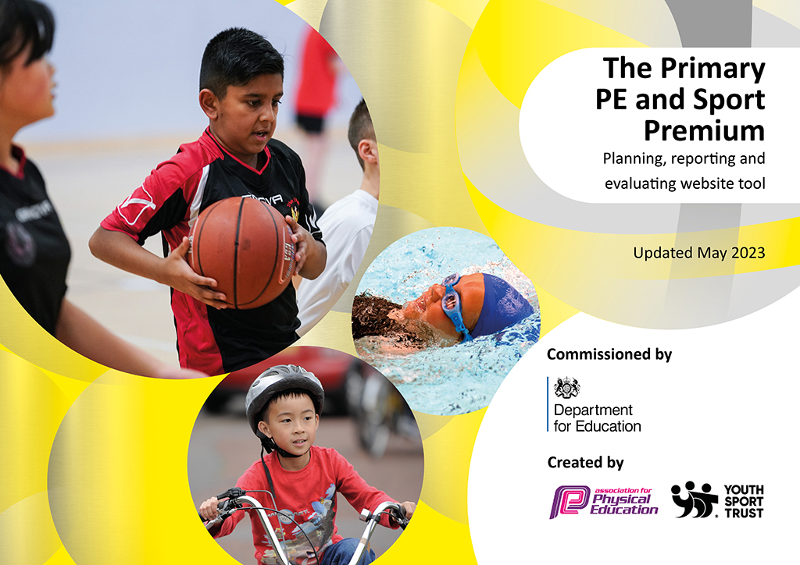
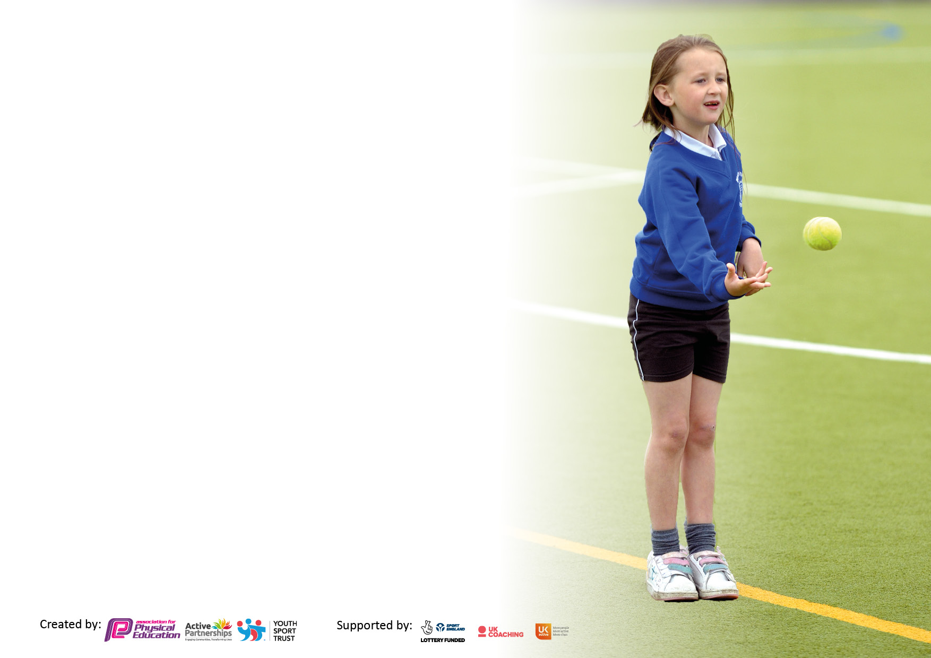

It is important that your grant is used effectively and based on school need. The Education Inspection Framework makes clear there will be a focus on ‘whether leaders and those responsible for governors all understand their respective roles and perform these in a way that enhances the effectiveness of the school’.

Under the Quality of Education Ofsted inspectors consider:
Intent - Curriculum design, coverage and appropriateness
Implementation - Curriculum delivery, Teaching (pedagogy) and Assessment
Impact - Attainment and progress

To assist schools with common transferable language this template has been developed to utilise the same three headings which should make your plans easily transferable between working documents.

Schools must use the funding to make additional and sustainable improvements to the quality of Physical Education, School Sport and Physical Activity (PESSPA) they offer. This means that you should use the Primary PE and sport premium to:

- Develop or add to the PESSPA activities that your school already offer
- Build capacity and capability within the school to ensure that improvements made now will benefit pupils joining the school in future years
- The Primary PE and sport premium should not be used to fund capital spend projects; the school’s budget should fund these.

Pleasevisitgov.ukfortherevisedDfEguidanceincludingthe5keyindicatorsacrosswhichschoolsshoulddemonstrate animprovement.Thisdocumentwillhelpyoutoreviewyourprovisionandtoreportyourspend.DfEencouragesschools to use this template as an effective way of meeting the reporting requirements of the Primary PE and Sport Premium.

We recommend you start by reflecting on the impact of current provision and reviewing the previous spend.

Schools are required to publish details of how they spend this funding, including any under-spend from 2021/2022, as well as on the impact it has on pupils’ PE and sport participation and attainment. All funding must be spent by 31st July 2023.

We recommend regularly updating the table and publishing it on your website throughout the year. This evidences your ongoing self-evaluation of how you are using the funding to secure maximum, sustainable impact. Final copy must be posted on your website by the end of the academic year and no later than the 31st July 2023. To see an example of how to complete the table please click HERE.

Details with regard to funding
Please complete the table below.

Total amount carried over from 2021/22 | £0
Total amount allocated for 2021/22 | £19,720
How much (if any) do you intend to carry over from this total fund into 2022/23? | £0
Total amount allocated for 2022/23 | £19,680
Total amount of funding for 2023/23. To be spent and reported on by 31st July 2023. | £ 0
Swimming Data
Please report on your Swimming Data below.

Meeting national curriculum requirements for swimming and water safety.

N.B. Complete this section to your best ability. For example you might have practised safe self-rescue techniques on dry land which you can then transfer to the pool when school swimming restarts.
Due to exceptional circumstances priority should be given to ensuring that pupils can perform safe self rescue even if they do not fully meet the first two requirements of the NC programme of study
What percentage of your current Year 6 cohort swim competently, confidently and proficiently over a distance of at least 25 metres?  N.B. Even though your pupils may swim in another year please report on their attainment on leaving primary school at the end of the summer term 2022.  Please see note above | 34%
What percentage of your current Year 6 cohort use a range of strokes effectively [for example, front crawl, backstroke and breaststroke]?  Please see note above | 10m front and back only – 44%  25m front and back only – 30%  25m front back and breaststroke – 1%
What percentage of your current Year 6 cohort perform safe self-rescue in different water-based situations? | 33%
Schools can choose to use the Primary PE and sport premium to provide additional provision for swimming but this must be for activity over and above the national curriculum requirements. Have you used it in this way? | Yes/No

Action Plan and Budget Tracking
Capture your intended annual spend against the 5 key indicators. Clarify the success criteria and evidence of impact that you intend to measure to evaluate for pupils today and for the future.

Academic Year: 2022/23 | Total fund allocated: £19680 | Date Updated: July 2023
Key indicator 1: The engagement of all pupils in regular physical activity – Chief Medical Officers guidelines recommend that primary school pupils undertake at least 30 minutes of physical activity a day in school |  |  |  | Percentage of total allocation:
 |  |  |  | Approx. 31%
Intent | Implementation |  | Impact
Your school focus should be clear what you want the pupils to know and be able to do and about  what they need to learn and to  consolidate through practice: | Make sure your actions to achieve are linked to your intentions: | Funding allocated: | Evidence of impact: what do pupils now know and what can they now do? What has changed? | Sustainability and suggested next steps:
Enhance outdoor sports provision at lunch and break time.  Introduce personal and paired challenges to engage pupils in physical activity.  Sports apprentice and Sports leaders to target inactive children across key stages 1 and 2. | -Sports apprentice to run lunchtime challenges.  -Appropriate equipment available for activities to enable all pupils to be access activity.  -Teachers to continue class participation in the ‘Daily Mile’ and the use of active brain breaks. | £6175 | -Results of challenges demonstrate increased participation in lunchtime activities and pupils are actively engaged, motivated to join in.  -Increased daily activity of pupils through personal challenge.  -Reduced reported behavioural incidents at break times as pupils engaged in supervised activity. | -SGC to train Sports leaders September 2023.  -Guidance on Active 30 to be disseminated at staff meeting.  -Tackle perceptions of healthy life style through lessons.  -CPD for lunchtime supervisors.
Key indicator 2: The profile of PESSPA being raised across the school as a tool for whole school improvement |  |  |  | Percentage of total allocation:
 |  |  |  | Approx. 12%
Intent | Implementation |  | Impact
Your school focus should be clear what you want the pupils to know and be able to do and about  what they need to learn and to  consolidate through practice: | Make sure your actions to achieve are linked to your intentions: | Funding allocated: | Evidence of impact: what do pupils now know and what can they now do? What has changed?: | Sustainability and suggested next steps:
-Implement a focus on self-challenge and resilience throughout all physical activity.  -Certificates to be awarded in assembly for achievement in PE linked to school values.  -Increase the percentage of children leaving KS2 with the ability to swim 25m | -Celebrate Sporting achievements in assemblies.  -Sports leaders support lunchtime and break activities, encourage all year groups.  -Sports leaders to support on Sports Days.  -Provide additional sessions the pupils who are yet to reach 25m in Year 6 | £2400 for extra swimming session | -Activities during sports day ensured positive participation for all pupils.  -Additional adult in PE sessions continued to provide additional intervention for those pupils who may otherwise have a less than positive experience in PE lessons.  -Pupils aware of extra curricula clubs available and competitions that have been entered. | -Ensuring parents and families know that PE is as important and any other subject.  -Continue to raise awareness of physical activities, for example, in assemblies.  -PE webpage up to date showing available activities, what has been achieved and up and coming events.

Key indicator 3: Increased confidence, knowledge and skills of all staff in teaching PE and sport |  |  |  | Percentage of total allocation:
 |  |  |  | 0%
Intent | Implementation |  | Impact
Your school focus should be clear | Make sure your actions to | Funding | Evidence of impact: what do | Sustainability and suggested
what you want the pupils to know | achieve are linked to your | allocated: | pupils now know and what | next steps:
and be able to do and about | intentions: |  | can they now do? What has
what they need to learn and to |  |  | changed?:
consolidate through practice:
-Raise the quality of learning and teaching in PE and school sport by providing support to deliver broad, balanced and inclusive high quality PE and school sport provision (within and beyond the curriculum) to raise pupils’ attainment.  - To encourage sports champion and sports apprentice support staff in lessons (to increase their confidence in delivery of the subject).  - Learning walk to monitor staff effectiveness and confidence. | -Use staff skills audit to identify training needs and where strengths are.  -Sports apprentice to work closely with teaching staff.  -New PE scheme to be purchased. | £0  Scheme to be purchased September 2023 | -Rugby coach worked with Year 4 teachers, one of which was not confident in teaching the subject.  -Tennis coach provided support to year 1 and 3.  -Sports apprentice worked in lessons supporting groups of pupils helping them achieve the lesson goal. | -Increase teacher knowledge in the benefits of physical education and methods to encourage children.  -PE lead to offer training opportunities for staff on Get Set 4 PE scheme in September 2023  -audit staff training needs and skills
Key indicator 4: Broader experience of a range of sports and activities offered to all pupils |  |  |  | Percentage of total allocation:
Intent | Implementation |  | Impact
Your school focus should be clear | Make sure your actions to | Funding | Evidence of impact: what do | Sustainability and suggested
what you want the pupils to know | achieve are linked to your | allocated: | pupils now know and what | next steps:
and be able to do and about | intentions: |  | can they now do? What has
what they need to learn and to |  |  | changed?:
consolidate through practice:
Additional achievements:  -Participation in Meols Cop dance festival  -Participation in Wally Cain dance festival  -Year 6 pupils given opportunity to attend residential with range of activities.  -Entry into the Swimming gala | -All Key stage 2 pupils to be offered extra curricula sports club.  -All Key stage 2 pupils to be offered extra curricula dance club.  -Sports apprentice to support in PE lessons, pre-teach SEND pupils. | £0 | -For Key Stage 2: 4 different Sports clubs offered each half term up to Spring 2.  -3 different Sport clubs offered each half term Spring 2 and Summer.  -Registers indicate that different pupils attended the clubs.  -Group of pupils had the opportunity to visit a Hillside Golf Club, participate in some golf activities and watch the amateur championships.  -Sports apprentice worked in lessons supporting groups of pupils helping them achieve the lesson goal. | -Target children to participate in extra curricula clubs and breaktime activities.  -Monitor clubs and analysis of uptake to adjust offer.

Key indicator 5: Increased participation in competitive sport |  |  |  | Percentage of total allocation:
 |  |  |  | Approx. 63 %
Intent | Implementation |  | Impact
Your school focus should be clear | Make sure your actions to | Funding | Evidence of impact: what do | Sustainability and suggested
what you want the pupils to know | achieve are linked to your | allocated: | pupils now know and what | next steps:
and be able to do and about | intentions: |  | can they now do? What has
what they need to learn and to |  |  | changed?:
consolidate through practice:
-To provide additional opportunities for pupils to represent the school at sporting events.  -Pupils to have access to extra curricula clubs which will give them the skills and confidence to enter competitions. | -Sports Champion to run after school clubs linked to School Games competitions.  -Inter school competitions entered.  -Intra school competitions to be used as an assessment opportunity in some areas. | £11363 Sports Champion  £1200 Swimming gala training | -A team was entered into the Southport Schools Swimming gala.  -The skill level of children continues to develop by allowing them to apply those which have been taught into a competitive context.  -Pupils have the opportunity to compete at intra competitions in PE lessons. | -Sports Premium funding to be used to transport pupils to competitions.  -Identify on School Games calendar competitions that we would like to enter.  -Offer some intra competitions after school.

