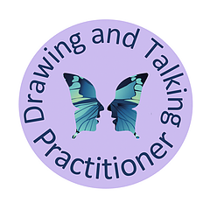

Parent and Carer Fact Sheet
Drawing and Talking is a child-centred one to one intervention focusing on supporting the social and emotional wellbeing of children and young people.

What Happens During Drawing and Talking Sessions?
Drawing and Talking is a safe and gentle therapeutic approach, which provides an effective way for children and young people to process emotions.
Children are impacted emotionally by many different events, struggles or traumas. Sometimes they are unable to make sense of how they are feeling and how those feelings are impacting on their happiness and ability to navigate the world.
We all want children to be happy and flourish. Your child will work one to one with a Learning Mentor who is a trained Drawing and Talking practitioner for 30 minutes, once a week over 12 sessions. Within the sessions, your child will draw anything they choose and will be encouraged to talk about feelings using storytelling language to help them make sense of their internal world.
The technique is intended to allow the child to play, by drawing a picture, and process any emotions they are holding internally in a safe and non-confrontational way, working at their own pace.
The sessions remain confidential between the child and the practitioner. At the end of each session, your child’s picture will be put into their folder and kept safely away until the next session. At the end of all the work (12 sessions), when the child is feeling better, the folder is handed back to your child for them keep as they wish.
Drawing and Talking is not intended to be used as a tool to ‘find out’ what is wrong or why the child behaves the way they do. It is not behaviour modification or used to fix a problem that a child has or is experiencing.
Practitioners do not interpret the pictures and do not ask direct questions. The technique should also not be used to replace other specialist services, (such as CAMHS, Psychotherapy, Art or Play therapy) but can be used as an interim tool whilst waiting to be seen by CAMHS or other professionals and can also be used after referral has been completed to complement external agencies.

For more information find us at: www.drawingandtalking.com or Facebook @drawingandtalking

